**Dear Friends,**

Recently, we had two incredible presentations with the Allegheny Intermediate Unit 3 on Wednesday, May 22nd and the Appalachia Intermediate Unit 8 on Monday, May 20th to present adaptive bikes, adaptive strollers, and communication devices!

**Allegheny Intermediate Unit 3:**

Excitingly, we held our first presentation in partnership with AIU3, and their team went all out to make the day extra special with balloons and a welcoming warmth. We presented 13 adaptive bikes, 3 adaptive strollers, and 3 communication devices, as well as fit 4 more kids for bikes.

**We were especially grateful to have Allegheny County Executive Rich Fitzgerald and Pennsylvania State Senator Pam Iovino join us for the special day and celebrate our kids.**

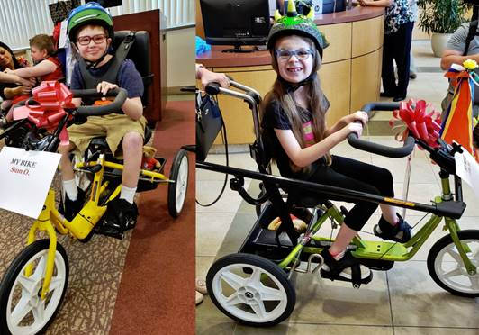

Children like 8-year old Sam (above left) and 7-year old Ella (above right) received their own customized adaptive bikes, and they couldn’t have been more excited!

Sam’s mom, Danielle explained the bike’s importance by saying, “**This bike is vital to Sam getting exercise. He is not able to walk unassisted now and even a walker is too difficult, so he mostly gets around in his medical stroller and sits a lot of the day. The bike gives him independence to get around and work his muscles and get some exercise**.”

Ella’s mom, Sarah also told us, “**As her Mother, it is heartbreaking to have to explain that there are certain limitations that Ella must endure for her own safety and due to her ability.**

**The positives that would come from Ella having an adaptive bike seem endless – building muscle strength, coordination and flexibility, improved balance, motor skills and body awareness. The list goes on! For our family, this bike is so important because Ella can finally feel what it is like to get out there and go, especially with her siblings! She just wants a chance to keep up with the other kids**.”

**Appalachia Intermediate Unit 8:**

Additionally, we presented 11 adaptive bikes, 11 adaptive strollers, and 7 communication devices, as well as fit 2 more kids for bikes with AIU8!

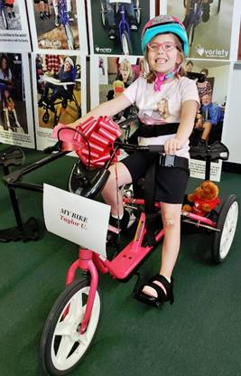

**For Taylor, age 7** (pictured above), a new adaptive bike means A LOT, and her mom, Ashlee explained why, “**As Taylor gets older, she is realizing things she is unable to do that her younger siblings are learning and that her peers have mastered. It hurts her feelings and lowers her self-esteem. I would love for her to be able to enjoy something as simple as riding a bike with her friends or us as a family. Her independence is important to her and to her father and me. While we can hold her on a bike or trailer, she is aware that she ‘should’ be able to ride alone and wants to so badly, but her depth perception, lack of balance, inability to pedal and her weak legs make it impossible on any typical bike**.”

It was also thrilling to see **Riley, age 16** (pictured below) get his new communication device, as he previously received an adaptive bike from Variety… He sums up the day perfectly using his device.

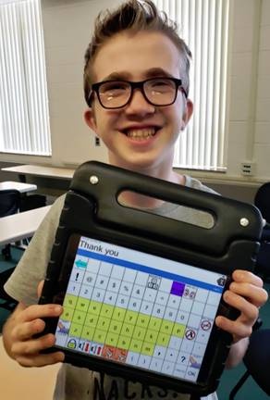

**A big shout out to our Intermediate Unit partners**, who are a huge component to making our programs a success and getting this life-changing equipment to eligible kids in need – and we couldn’t be more grateful.

Take good care,

Charlie